LDA Washington Website Project
Learning Disabilities Association
October 23, 2011

Table of Contents
1 Overview 3
1.1 Vision 3
1.1.1 Parents 3
1.1.2 Professional 3
1.1.3 General Public 3
1.2 General Information 3
1.3 Site Information 3
1.3.1 Current Web Site 3
1.3.2 New Web Site 3
2 Features 4
3 Pages 5
3.1 Home Page 5
3.2 Navigation Map 5
Table of Figures
No table of figures entries found.

Overview
The purpose of the project is to provide a website for the Learning Disabilities Association(LDA). LDA mission and vision:

Mission
The Learning Disabilities Association (LDA) of Washington promotes and provides services and support to improve the quality of life for individuals and families affected by learning and attention disabilities.

Vision
A world in which:
- All individuals with learning disabilities are empowered to thrive and participate fully in society;
- The incidence of learning disabilities is reduced; and
- Learning disabilities are universally understood and effectively addressed.
We respect and honor the diversity of our community and are committed to weaving that diversity into our programs, actions, and results.

Vision
The purpose of the LDA website is to provide resources and information to people with an interest in helping families with children with learning disabilities improve their quality of life. There are 3 customer types for the website:

Parents
Parents of children with ADHD. For parents the website will provide:
- Information to parents of children with learning disabilities
- Resources for parents

Professional
People qualified to assist with improving the quality of life of families affected by learning disabilities. These may include; Attorneys, ADHD coaches, Counselors, Treatment Centers, Therapists, Specialists, Tutors and Consultants. The website will provide professionals:
- With information on how to deal with children with ADHD.

General Public
The website will help interested individuals to become involved with the LDA, by providing resources to:
- Learn about the organization
- Understand the problems with ADHD
- Get involved with the organization

General Information
Includes A forum where all customers may discuss the LDA and resources to assist with ADHD. A calendar of events of interest to website customers. Other information and useful links to sites throughout the USA, N.America and the rest of the world. Contact information for people needing additional resources not supplied on the website.

Site Information
Stuff here about hosting, the URLetc.

Current Web Site
Describe what works and what doesn't on the current website
Current website is little more than a home page containing an overview of the LDA and information that it would like the site to provide. It contains duplicate links, missing information, inconsistent look and feel and most of the site pages have only draft (overview) content.

New Web Site
What is to change and additional features for the new website.
Keep all of the functions that the original website is intended to provide; links for parents professionals and the general public, as well as general LDA information, a calendar of events and contact information.

Features
list of features for the website
- secure payment for:
- online donations
- events
- books and purchased items
- members only area for:
- forums
anything else?
- making inquiries
- calendar of events
- latest news
- social networking
- access to facebook groups
- sign-up for twitter messages
- linkedin?
- library of news, events, streaming media, presentations, downloads, flash images
database of professional service providers (e.g., OT/PT, learning centers, schools, etc.)
- Clearing house of online and print information regarding LDs in a dynamic, interactive database
- Optimized for discovery by search engines (Google, Yahoo, Bing ..)

- Admin log in with what you see is what you get interface for adding or removing video, audio, image, and text in real time
- Accessibility for foreign language customers

Site Map
Describe the purpose of each page and the features that it will provide.
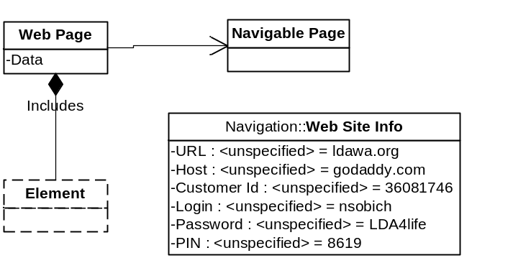
- Diagram Legend
- Web Site Info – about the web site
- Web Page - is a page on the site
- Navigable Page – a page that can be navigated to from a link on another web page
- Element – web part or information that is on a web page (there may be many of them).
For example:
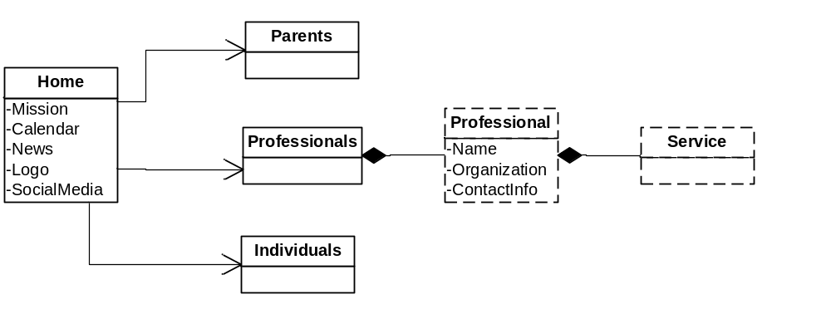
- Example Structure
From Home page you can navigate to Parents, Individuals and Professionals pages. Professionals page includes a list of Professional. Each Professional includes a list of services provided by the professional.

Pages
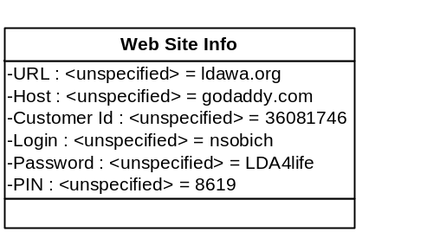

Home Page
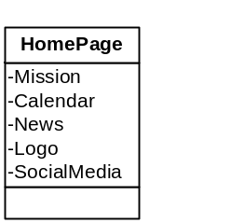
- Mission –
- Calendar –
- News –
- Logo –
- SocialMedia –

Navigation Map
Describes how the pages are linked.
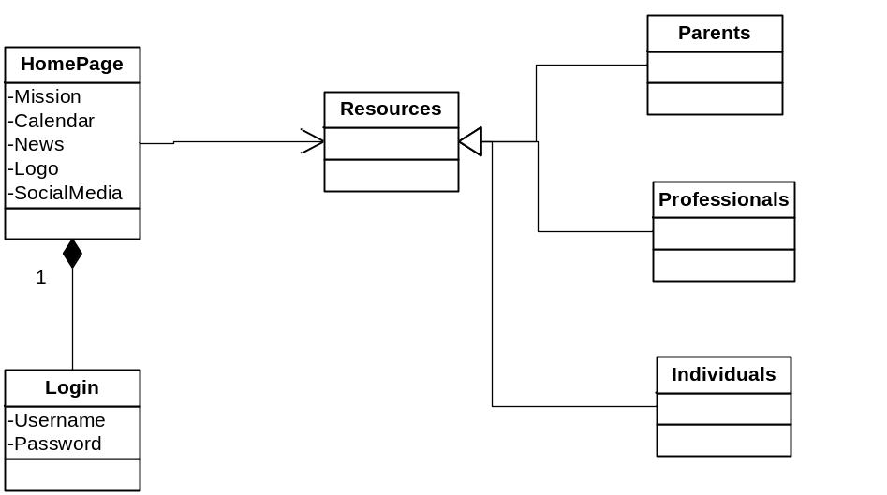

LDA WA WEBSITE
Current Website
www.ldawa.org
Host: GoDaddy
Customer number: 36081746
Login: nsobich
Password: LDA4life
Pin: 8619
NEW WEBSITE FEATURES WISHLIST
1) Secure online payment (including PayPal)
a. ability to join, renew, and donate
b. pay for and register for events
c. online bookstore
2) Members only login
a. forum
b. other resources
3) Inquiry form
5) Calendar of events (revisable)
6) News (home page)
9) Social networking:
a. Facebook: password: Learn4123; profile: www.facebook.com/pages/Learning-Disabilities-Association-of-Washington/40523505876?v=info
b. Twitter: password: leap4lda; profile: https://twitter.com/#!/LDAWASH
10) Online library of recorded events (conferences, presentations, video, audio, if possible)
11) Database of professionals and service providers (e.g., OT/PT, learning centers, schools, etc.)
12) Clearing house of online and print information regarding LDs in a dynamic, interactive database
13) Search engine optimization
14) Flash capable for display of images
15) Admin log in with what you see is what you get interface for adding or removing video, audio, image, and text in real time
16) Accessibility
www.webaim.com
http://webaim.org/articles/scenarios/
http://www.w3.org/WAI/

HOME PAGE
Favored look/feel: www.ldaminnesota.org or www.dartmoorschool.org
Home page with main graphic and mission (as with LDA MN site) or rotating images (Dartmoor) with horizontal and vertical tabs (please see below)
Calendar, news, social media buttons, and login
Logo
HORIZONTAL TABS
About LDA WA
- Mission and Vision
- History
- Board and Staff
What Is LD?
- Overview of LD
- Facts about Learning Disabilities
- LD Resources (add articles and content)
  - Parents
  - Professionals
  - Individuals
What Is ADHD?
- Overview of ADHD
- Facts about ADHD
- ADHD Resources (add articles and content)
  - Parents
  - Professionals
  - Individuals
Resources
- Professional Referrals
- Support (organizations and support groups)
- Web Resources
- Print Resources
Get Involved
- Donate
- Volunteer
- Join
- Attend (LDA events)
Contact LDA WA
(contact info plus Google maps)

VERTICAL TABS
Parentslinks to “Parents” home page with introductory content and links to LD and ADHD parent resources (see above)
Professionals links to “Professionals” home page with introductory content and links to LD and ADHD professional resources (see above)
Individuals links to “Individuals” home page with introductory content and links to LD and ADHD individuals resources (see above)
- Professional Referrals

Welcome to Learning Disabilities Association of Washington professional referral section where information and support thrive. Our organization is here to help people with Learning Disabilities and Attention Deficit Disorder achieve their full potential through education and support.

The Learning Disabilities Association of Washington offers referrals to appropriate, qualified professionals.
For your convenience the list below contains the names of professionals who are current members of the Learning Disabilities Association of Washington.

LDA does not recommend or endorse any one specific diagnostic or therapeutic regime, whether it is educational, psychological, or medical

For more information contact Nancy Sobich at
425-882-0820 nsobich@ldawa.org

ADVOCACY AND SCHOOL REFERRAL SERVICES FOR STUDENTS WITH LD/ADHD

Barbara Bennett,
Seattle 206-325-2522
Educational Therapist

Debra A. Boyle, M.Ed.,
Redmond 425-868-5648
Educational Consultant, Cognitive Developer (Tutor) and Student Advocate

Norma Jean Campbell, M.Ed. Campbell & Associates
Richland 425-802-8662
Consulting for children and adults

Deborah Cossey, M.Ed., Rainier College Counseling
Woodinville 425-483-5869

Claire Nold-Glaser, M.Ed.
Bellevue 425-373-1192
College planning & consulting

ARK Institute of Learning Educational Consultants
Tacoma 253-573-0311

ATTORNEYS

Jeannette Cohen, M.Ed. JD
Shoreline 206-542-7234

ADHD COACHES

Neil Peterson, Edge Foundation
Seattle 206-632-9497

Dartmoor School
Bellevue, Issaquah, Seattle, Woodinville 425-885-6296
Grades 1-12, HS diploma/College Prep, Academic Support

COUNSELORS

ARK Institute of Learning
Tacoma 253-573-0311

Behavior & Child Development Associates
Seattle 206-361-6884
Testing and counseling of children

Owen Judson Bargreen, Psy.D.
Everett 425- 303-0201
Testing for LD

Brad Bates,PhD.
Tacoma 253-383-0101
LD testing for ages 16 and older

Nicole Cole, LICSW, MA
Seattle, Marysville, Arlington 425-387-2113
Assessments for LD and AD/HD. Psychotherapy for adults

Andrew B. Forsyth, Ph.D.
Spokane 509-353-9855
Provides testing for LD and AD/HD - all ages

Angela Hangelmann, Ph.D
Seattle 206-729-2829 X 7
Testing children and adolescents

Jared Hellings, Psy.D
Everett 425-259-1366
Assessments for LD and AD/HD for adults

Betty Jones, Ph.D., Diagnostic Associates
Bellevue 425-455-2938
Testing children and adults

Gwen A. Lewis, Ph.D., A.B.Pd.N GAL Neurodiagnostic Services LLC
Edmonds 425-672-1850

Ellen Walker Lind, Ph.D.,LMHC, Lind Psychological Services, INC
Bellingham 360-738-4916
Testing for LD for all ages

Wendy Marlowe, Ph.D. ABPP-CN
Seattle 206-623-5217
Neuropsychological assessments of children and adult

Elizabeth P. MacKenzie, Ph.D.
Seattle 206-932-2590
Assessments and consultations

Roderick Mahurin, Ph.D. Cascade Neuropsychological
Edmonds 425-640-6134
Testing for LD

Beverly J. Norfleet, Psy.D.
Bellevue 425-455-7861
Testing and psychotherapy for all

Payne and Associates
Seattle, Tacoma, Olympia, Bellevue 360-491-760
Testing for LD

Elizabeth A. Smith, Ph.D., KinderMinds
Bellevue 425-301-1816
Testing for LD and Dyslexia for children

Arthur Williams, Ph.D.
Shoreline 206-362-4453
Testing for LD

Jane M. Wootton, Ph.D
Seattle 206-729-2829 x 2
Neuropsychological assessments for LD & ADHD

Melinda Johnson, LICSW
Richland 509-946-1309
Counseling Services

Douglas Whiteside
Everett 425-259-1366 x 5
Neuropsychological assessments for LD/ADHD for all ages

ADHD EVALUATION AND TREATMENT

Northwest ADHD & Behavioral Medicine
Kirkland 425-821-9730

Ted Ritter, ARNP, Academic Institute, Inc
Bellevue 425-401-6844

COUNSELORS, M.S.W. M.S. M.Ed.

George T. Lynn, M.A., LMHC,
Bellevue 425-454-1787
Counseling for all ages

OCCUPATIONAL/PHYSICAL THERAPISTS

Rosemary White, OTR,
Shoreline 206-367-5853
Pediatric Physical & Occupational Therapy

OPOTOMETRISTS/VISION SPECIALISTS

Marlene Inverso, OD, American Family Vision Clinic,
Olympia 360-491-2121

TUTORING AND CONSULTING

ARK Institute of Learning
Tacoma 253-573-0311

Barbara Bennett, M.A.
Seattle/Eastside 206-325-2522
Educational Therapist

Debra A. Boyle, M.Ed.
Redmond 425-868-5648
Academic Tutor

Dartmoor School
Bellevue, Issaquah, Seattle, Woodinville 425-885-6296
Grades 1-12, College Prep, Transitions

Norma Jean Campbell, M.Ed. Campbell & Associates
Richland 425-802-8662

Janet Dolan, M.Ed., Dolan Learning Center
Woodinville 425-488-3587

Linda Gorsuch, B.A., Sp.Ed.
Blaine 360-371-3978
Academic tutoring

Judith A. Hewitt, M. Sp.Ed.
Bothell 206-323-9011
Academic tutoring
Keys to Success Tutoring

Susan B. Klastorin, M.Ed.
Seattle 206-322-1258
Basic Skills Tutoring

Lindamood-Bell Learning Processes
Bellevue 425-827-6288
Learning Support, Summer Programs

Caroline R. Mass, SPED
Seattle 206-527-1869

Dianne Matthaei, Lighthouse Learning, LLC
Tacoma 253-779-5032

Mary Sweet, Northshore Learning Alliance
Woodinville 425-485-9421

Educational Advancement Academy (EA2)
Bellevue Seattle 206-284-2300

Ruth Wilson, M.A.
Sammamish 425-836-1600

Laurie Ulmer
Winthrop 509-429-9460

Melanie Weiss, M.Ed
Bellevue 425-746-5745

Academic Institute, Inc
Bellevue 425-401- 6844

NORTHWEST PRIVATE SCHOOLS FOR LEARNING DISABILITIES AND ATTENTION DEFICIT DISORDER STUDENTS

Dartmoor School
Bellevue, Issaquah, Seattle, Woodinville 425-885-6296
Grades 1-12, HS credit, diploma/College Prep, Summer Programs

Morningside Academy
Seattle 206-709-9500

New Horizon School
Renton 425-226-3717

Academic Institute, Inc
Bellevue 425-401- 6844
Classes for Middle and High School

- Additional Resources
For Parents
Coming soon!
For Professionals
Coming soon!
For Individuals
Coming soon!
- Our Team
Meet the Team
BOARD & STAFF

LEARNING DISABILITIES ASSOCIATION WASHINGTON
Board of Directors (2010)
Executive Board

Elizabeth Smith, PhD
President
Neuropsychologist

Meagan Norlin
Vice President
Center Director Lindamood-Bell, Bellevue

Lee Kueckelhan
Immediate Past President
Acting Treasurer
Senior Partner (Retired) - Kueckelhan, Crutcher& Co.

Phil Mortenson
Secretary
Contract Attorney with AvauadeInc
Active member of the California and Washington Bar Associations

Directors at Large

Nancie Payne, PhD
Payne and Associates Inc., President & CEO
Learning Disabilities Association of America, Board of Directors
Commission on Adult Basic Education, Member
Thurston Economic Deuman Resource Development Council, Board of Directors
Thurston County Chamber of Commerce, member

Jeffrey D. Woolley, MA, MIT
Head of School at Dartmoor School
President, ADD Resources Board of Directors
Board Member, Adelphi Advisory Board (Ryther)
Adjunct Faculty, Portland State University

Sam DiGiacomo
Karen Walters

STAFF
Nancy Sobich
Director of Information and Referral
nsobich@ldawa.org
- Contact Information
CONTACT US
Learning Disabilities Association of Washington (LDA WA)
16315 NE 87th Street Suite B-11
Redmond WA 98052
Phone: 425-882-0820
email: @ldawa.org

- FACTS
FACTS ABOUT LEARNING DISABILITIES
Who experiences Learning Disabilities
- People with learning disabilities generally have average or above average intelligence. Their learning disability, however, creates a gap between ability and performance.
- Learning disabilities often run in families.
- Fifteen percent of the U.S. population, or 39 million Americans, have some form of learning disability.
- Fifty percent of all public school students in special education have learning disabilities.
What Can Be Done to Help Children with Learning Disabilities
- Early identification of youngsters with learning disabilities makes a critical difference in helping them learn the skills they need to compensate.
- Intervention by school personnel, who are required by law to create and carry out an Individualized Education Program (IEP), can help a youngster develop the skills to cope with his or her learning disability.
- Support from parents and educators is vital to help children with learning disabilities reach their full potential.
What Happens When Learning Disabilities Go Untreated
- People with learning disabilities that have not been diagnosed or properly addressed, or who are deemed "ineligible" for treatment, can experience serious, life-long negative consequences. The results can include loss of self-esteem, delinquency and illiteracy. The individual, as well as our society, is harmed.
- Thirty-five percent of students identified with learning disabilities drop out of high school, contributing greatly to the nation's school dropout rates.
- Fifty to eighty percent of adults with severe literacy problems have undetected or untreated learning disabilities.
- Fifty percent of young criminal offenders tested were found to have previously undetected learning disabilities. When offered educational services that addressed their learning disability, the recidivism rates of these young offenders dropped to below two percent.
Up to sixty percent of teens in treatment for substance abuse have learning disabilities.

- HISTORY
In 1964 a small group of parents in Edmonds, Washington, concerned about their learning disabled children, formed the first chapter of Learning Disabilities Association of Washington (then called Washington Association for Children and Adults with Learning Disabilities, or WACLD). The association was incorporated in 1964 and became the Washington State affiliate of the National Association for Children with Learning Disabilities (ACLD).
That same year the Seattle Chapter was also started by a group of 75 parents and professionals intensely concerned about a new field – learning disabilities (LD). This chapter and its first officers later became the State-based association.
Concern for the lack of education and understanding for their learning disabled children, prompted members of the association to work for an amendment to special education legislation in 1969 to include educational services for learning disabled within education for the handicapped. Following passage of this legislation, members proceeded to assure that every school district in the state included programming for learning disabled. Identification, definition, and appropriate programming for these children became a long-term goal of the association and remain a continuing goal.
The association continued to grow, working out of a church basement, forming chapters and sponsoring conferences for parents and professionals to bring about an awareness of this “hidden handicap," which many did not believe existed. Members started educating school officials, professionals, government officials, members of the legal community and the public-at-large.
A prominent Seattle judge who agreed to do research on LD for a WACLD sponsored conference became a “believer” when he realized many children who came through his court were in fact LD. "A Judge Looks at Learning Disabilities" became a popular reading piece on LD as a result of his research.
Dr. Frank Brouilett, Superintendent of Public Instruction for the State of Washington, became an early supporter of WACLD, and served on WACLD’s Advisory Board of professionals.
WACLD members were involved in helping draft the first set of rules and regulations for education of the handicapped prior to the adoption of House Bill 90 in 1971, providing services to all handicapped children in the State of Washington. They informally joined forces with a group called “Education for All” who worked for the successful passage of H.B. 90. Following passage of H.B. 90, concern arose about the fiscal impact of this legislation on Washington State. Governor Dan Evans and Dr. Frank Brouillet, put together the Washington State Special Education Coalition to do months of intensive study, the commission concluded that 3% of the children with learning disabilities needed special services. Thus, learning disabilities finally gained recognition, officially, as needing services. In 1975 the Federal Government passed the “Education for All Handicapped” (PL94-142) law that provided protection and rights in all states.
Recognition and services for learning disabilities came slowly. All along there has been a problem in defining LD, many politicians over the years have wanted “a tighter definition." The work continues today by the many individuals and agencies who are concerned with keeping the services and protections for learning disabled children and adults; the very services that parents fought so hard for -- many years ago.
We are now called the Learning Disabilities Association of Washington. Our national affiliate, Learning Disabilities Association of America, changed its name so individuals could easily locate the many LDA’s across the country.

